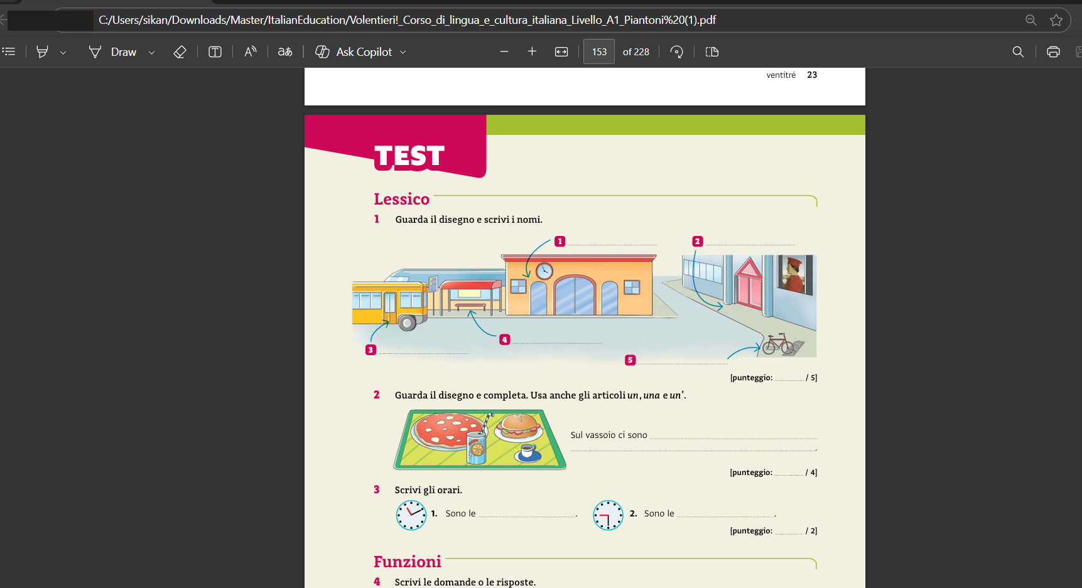
Sad

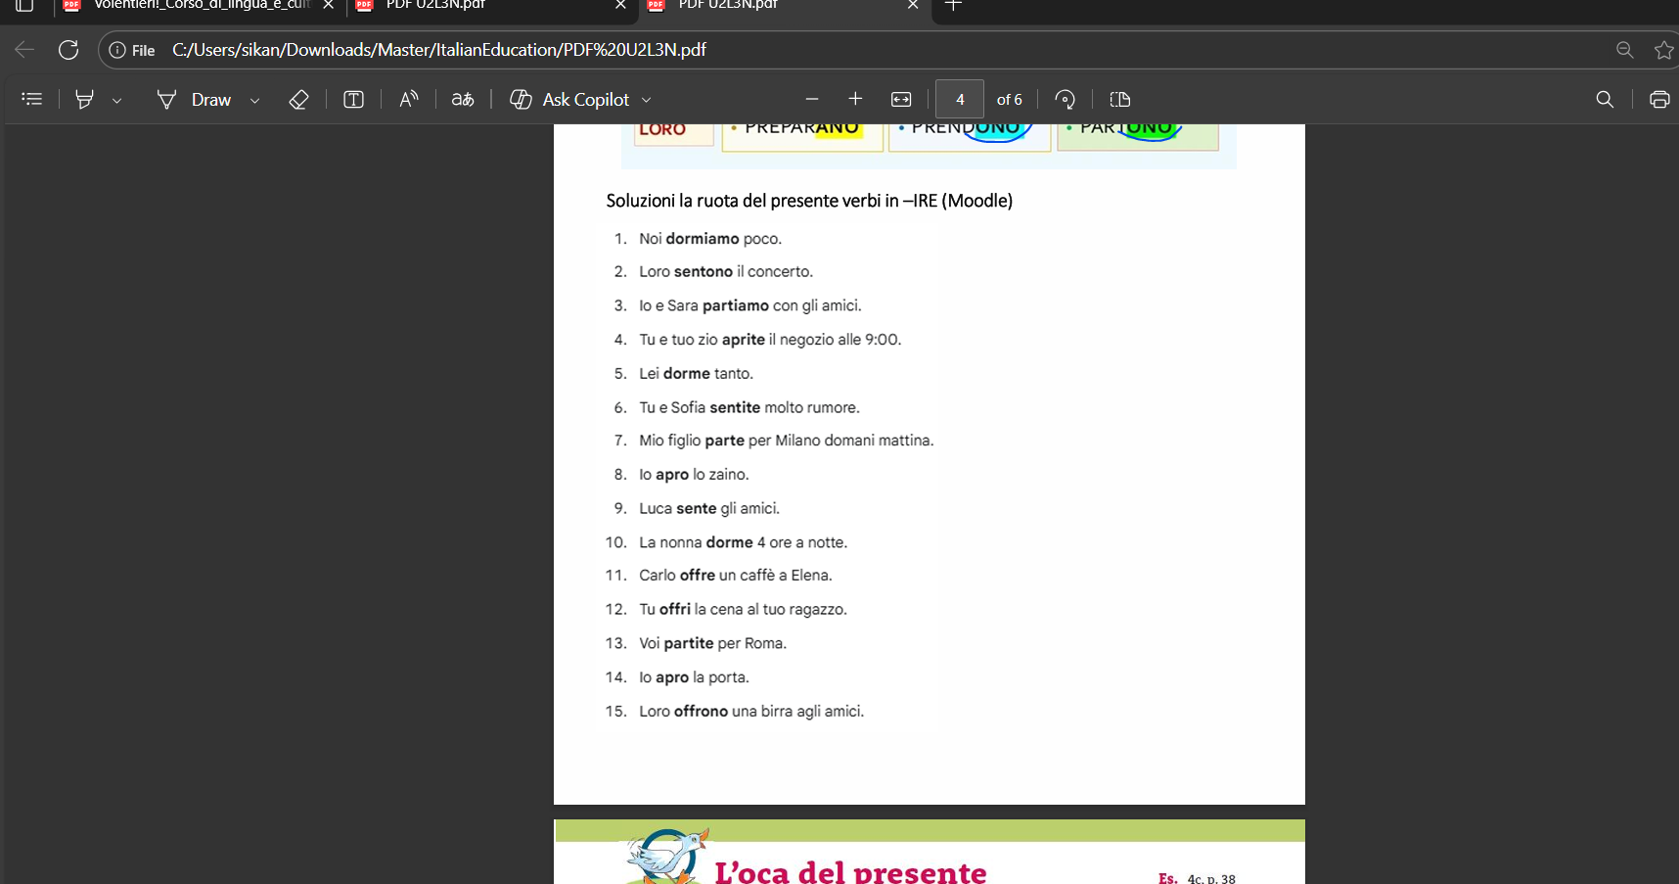
solution for the lesson3 moodle spin the wheel exercise, some form of sentences had to be made

